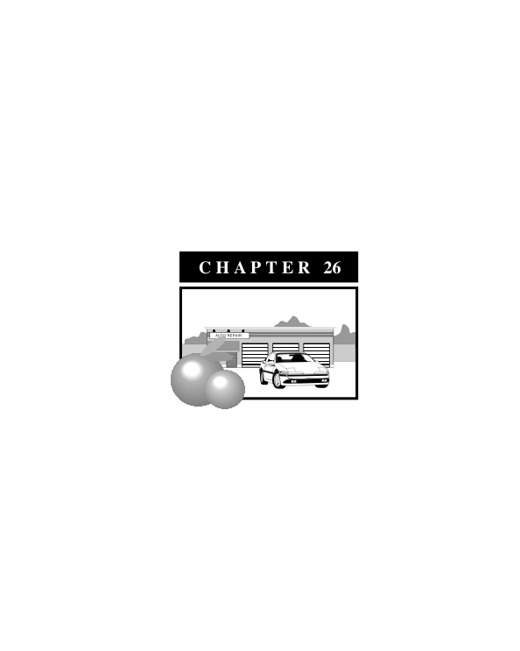

**CS Zone (Service Commercial)**

**Sections**

**17.26.01 Purpose**

**17.26.02 Permitted Uses**

**17.26.03 Accessory Uses**

**17.26.04 Conditional Uses**

**17.26.05 Site Plan Review**

**17.26.06 Development Standards**

**17.26.07 Fences, Walls and Hedges**

**17.26.08 Off-Street Parking and Loading Facilities**

**17.26.09 Signs**

**17.26.10 Landscaping**

**17.26.11 Design Standards**

**17.26.12 Special Conditions**

**17.26.01 Purpose**

The purpose of the Service Commercial (CS) district is to provide locations for wholesale and heavy commercial uses and service establishments that are not suited for other commercial zones. It also provides areas for certain light industrial uses which manufacture, assemble or package products within buildings and which do not emit fumes, odor, dust, smoke or gas.

The service commercial uses shall be developed in buildings and complexes that exhibit high standards of design, including sites where generous amounts of landscaping, screen outdoor storage, repair and assembling areas from the public’s view and where the impact of noise, vibrations, and light on surrounding properties are minimized.

**17.26.02 Permitted Uses**

A. Auto repair garages and associated operations

B. Glass shops

C. Gun shops

D. Heating, air conditioning and sheet metal shops

E. Household and office equipment and machinery repair

F. Laundries and linen supply services

H. Lumber yards

I. Machinery sales and rentals

J. Motorcycle sales and repair

K. Nurseries and garden supply stores

L. Plumbing and sheet metal shops

M. Printing, lithographic and engraving

N. Public utility yards

O. Refrigeration equipment sales and service

P. Rug and carpet cleaning

Q. Safe and vault manufacturing and repair

R. Sign painting shops

S. Stone and monument yards

T. Storage garages and yards, warehouses and mini-storage facilities

U. Tire sales and service, upholstery shop, radiator shops, body and fender shops

V. Welding and blacksmith shops

W. Wholesale establishments

X. Offices and retail stores incidental to and on the same site with a service commercial establishment.

Y. Utility and water works facilities

Z. Other uses that are added to this list by the Planning Director consistent with Chapter 17.02 General Provisions.

**17.26.03 Accessory Uses**

Those uses and structures incidental to the commercial use of the land, including trash storage areas and bins; required loading and unloading facilities; radio and television antennas; storage and use of fuels for fleet use; showrooms and administration offices; and other uses and structures, which are determined by the Planning Director to be incidental to the commercial use of the land.

**17.26.04 Conditional Uses**

A. Public buildings and grounds.

B. Churches and other religious institutions

C. Small- animal boarding, hospitals, clinics, kennels and veterinarians

D. All uses permitted in the ML district.

E. Other uses that are added to this list by the Planning Director consistent with Chapter 17.02 General Provisions.

**17.26.05 Site Plan Review**

No development shall be constructed on any lot or site in this district until a site plan has been submitted and approved consistent with Chapter 17.54 Site Plan Review.

**17.26.06 Development Standards (see also Exhibit 26-1)**

A. Site Area

The minimum site area shall be 10,000 square feet.

B. Lot Frontage and Depth

No requirement.

C. Building Height

The maximum height shall be 45 feet. The maximum height of accessory structures shall be 35 feet.

D. Yards

1.Front: 15 feet

2. Side: except where the CS district abuts a R district in which case the side yard requirement shall be 10 feet.

3. Rear: No requirement, except where the CS district abuts a R district in which case the rear yard requirement shall be 10 feet.

**Exhibit 26-1: Zoning Standards**

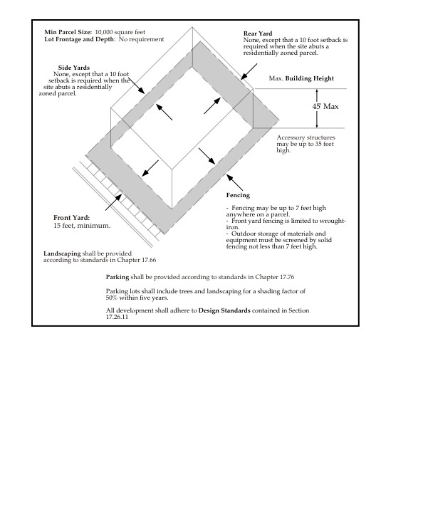

**17.26.07 Fences, Walls and Hedges**

A. Where the CS district abuts a R district, a 7-foot solid block wall shall be constructed on the property line that separates the two districts.

B. The outdoor storage of equipment or materials shall be screened from the view of any adjoining public right-of-way with a 7-foot solid block wall, or 7-foot chain-linked fence with slats and landscaping.

C. Fencing in the front yard shall be limited to wrought-iron fencing.

**17.26.08 Off-Street Parking and Loading Facilities**

Off-street parking and loading facilities shall be provided for each use as required by Chapter 17.68 Parking and Loading.

**17.26.09 Signs**

Signs shall be consistent with the requirements detailed in Chapter 17.69 Signs.

**17.26.10 Landscaping**

A landscaping and irrigation plan shall be submitted to the City Planner for review and approval. If the landscaped area exceeds 2,500 square feet in area, the landscaping and irrigation plan shall be prepared consistent with Chapter 17.66 Landscaping, Irrigation and Grading.

**17.26.11 Design Standards**

A. All metal buildings shall be designed with a front facade that is composed of a material other than metal, including stucco, brick, rock or wood. The front facade of these buildings shall contain a recognizable bulkhead, cornice and combination of window and door openings. These openings can be accented with awnings.

B. All front yard fencing shall be wrought-iron or wrought-iron with columns composed of brick, stucco, concrete or some combination.

**17.26.12 Special Conditions**

No use shall be permitted, and no processes, equipment, or materials shall be used which are found to be injurious to persons living or working in the vicinity by reasons of odor, fumes, dust, smoke, cinders, dirt, refuse, water-carried waste, noise, vibration, illumination, glare of unsightliness or to involve any hazard of fire or explosion.