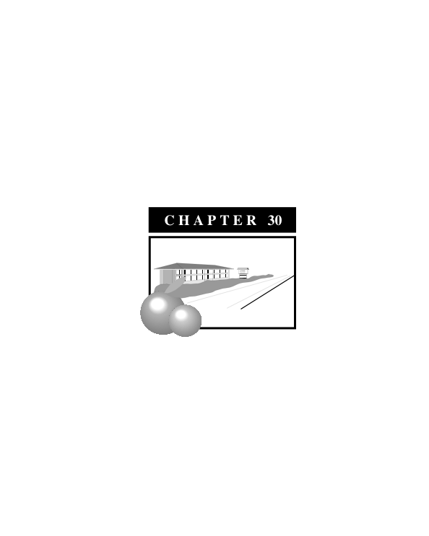

**CH Zone (Highway Commercial)**

**Sections**

**17.30.01 Purpose**

**17.30.02 Permitted Uses**

**17.30.03 Accessory Uses**

**17.30.04 Conditional Uses**

**17.30.05 Site Plan Review**

**17.30.06 Development Standards**

**17.30.07 Fences, Walls and Hedges**

**17.30.08 Parking and Loading**

**17.30.09 Signs**

**17.30.10 Landscaping**

**17.30.11 Design Standards**

**17.30.01 Purpose**

The purpose of the Highway Commercial (CH) district is to provide locations along arterial roadways to afford the traveling public the opportunity to take advantage of the provision of certain goods and services, including hotel and motel services, and the sale of food, gasoline, and commodities grown in the region.

Highway commercial uses shall be developed in buildings and complexes that exhibit high standards of design, including sites that include generous amounts of landscaping, ample on-site parking, properly scaled signage and buildings that are attractive and are consistent with the scale of Exeter.

**17.30.02 Permitted Uses**

A. Bus depots and transit stations

B. Convenience stores

C. Fruit stand

D. Hotels and motels

E. Parking lots

F. Public utility structures, services and facilities, including gas and electrical distribution and transmission substations, gas regulator stations and public service pumping stations

G. Private clubs and lodges

H. Repair garages associated with a service station

I. Restaurants, including drive-in restaurants

J. Service stations

K. Other uses that are added to this list by the Planning Director, which are consistent with Chapter 17.02 General Provisions

**17.30.03 Accessory Uses**

Those uses and structures incidental to the commercial use of the landing including, trash storage areas and bins; required loading and unloading facilities; radio and television antennas; the storage and use of fuels for fleet use; and other uses and structures which are determined by the Planning Director to be incidental to the commercial use of the land.

**17.30.04 Conditional Uses**

A. Churches and other religious institutions

B. Golf driving ranges; miniature golf; race tracks; riding facilities; and other similar commercial recreational facilities.

C. Public buildings and grounds

D. Trailer parks and courts

E. Car washes

**17.30.05 Site Plan Review**

No development shall be constructed on any lot or site in this district until a site plan has been submitted and approved consistent with Chapter 17.54 Site Plan Review.

**17.30.06 Development Standards (see also Exhibit 30-1)**

A. Site Area

The minimum site area shall be 10,000 square feet.

B. Lot Frontage and Depth

No requirement.

C. Building Height

The maximum height shall be 45 feet. The maximum height of accessory structures shall be 35 feet.

D. Yards

1.Front: 20 feet

2. Side: None, except where the CH district abuts a R district in which case the side yard requirement shall be 10 feet.

3. Side yard that abuts a street: 20 feet

4. Rear: No requirement, except where the CH district abuts a R district in which case the rear yard requirement shall be 10 feet.

**17.30.07 Fences, Walls and Hedges**

A. Where the CH district abuts a R district, a 7-foot solid block wall shall be constructed on the property line that separates the two districts.

B. The outdoor storage of equipment or materials shall be screened from the view of any adjoining public right-of-way with a 6-foot solid block wall, or 6-foot chain-linked fence with slats and landscaping.

C. Fencing in the front yard shall be limited to wrought-iron fencing.

**Exhibit 30-1: *Zoning Standards***

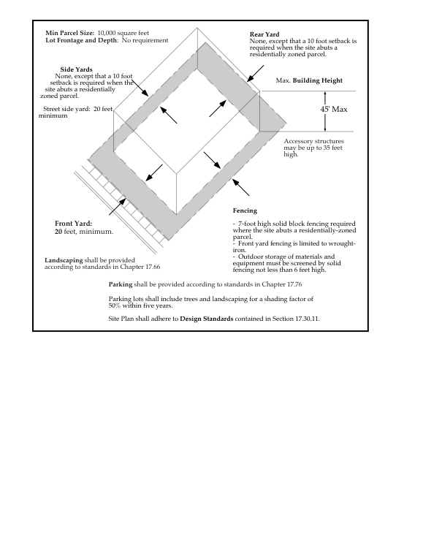

**17.30.08 Parking and Loading**

Off-street parking and loading facilities shall be provided for each use as required by Chapter 17.68 Parking and Loading.

**17.30.09 Signs**

Signs shall be consistent with the requirements detailed in Chapter 17.69 Signs.

**17.30.10 Landscaping**

A landscaping and irrigation plan shall be submitted to the City Planner for review and approval. If the landscaping area exceeds 2,500 square feet, the landscaping and irrigation plan shall comply with the regulations contained in Chapter 17.66 Landscaping, Irrigation and Grading.

**17.30.11 Design Standards**

A. The highway commercial project shall not contain more than two access driveways per street.

B. Outdoor storage, loading and equipment areas shall be screened from public view.

C. Large, blank unarticulated wall surfaces that are visible from the public right-of-way shall be discouraged.

D. Utilize low profile walls and landscaping to screen parking lots from the public right-of-way. Earthen berms can also be used to screen the parking lot.

E. Entryways into a parking lot shall be bracketed by landscaped bulbouts. These bulbouts may also contain monument signs or directional signs.

F. Where a highway commercial development occupies a corner lot, the corner shall be articulated with landscaping, low profile walls and signage, lighting and hardscape.

G. Parking lots with more than 20 stalls shall be provided with raised, landscaped medians that will be planted with shade trees. Within five years of the completion of the parking lot, the selected shade trees should shade at least 50 percent of the parking lot.

H. Lighting should be used to illuminate on-site areas such as parking, loading and pathways. Adjacent residential properties shall not be illuminated by a highway commercial use.

I. All roof-mounted equipment shall be screened from public view.