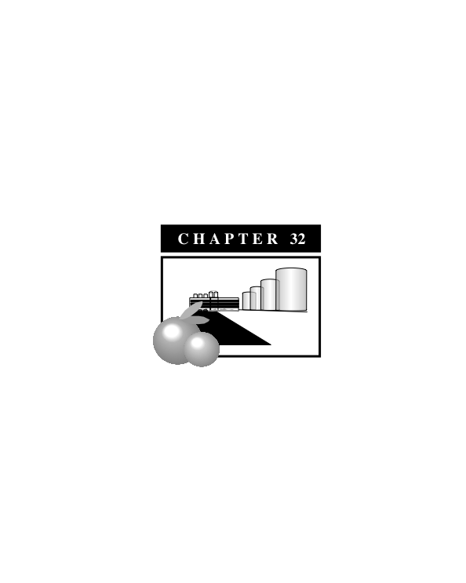

**I Zone (Industrial)**

**Sections**

**17.32.01 Purpose**

**17.32.02 Permitted Uses**

**17.32.03 Accessory Uses**

**17.32.04 Conditional Uses**

**17.32.05 Site Plan Review**

**17.32.06 Development Standards**

**17.32.07 Fences, Walls and Hedges**

**17.32.08 Off-Street Parking and Loading Facilities**

**17.32.09 Signs**

**17.32.10 Landscaping**

**17.32.11 Design Standards**

**17.32.12 Performance Standards**

**17.32.01 Purpose**

The purpose of the Industrial (I) district is to provide appropriate locations in the community for industrial uses and related activities. The development shall be consistent with the Exeter General Plan and be limited to industrial and service commercial uses. Regulations are designed to promote the following: (1) to protect appropriate areas for industrial use from intrusion by residences and other harmonious uses, (2) to provide opportunities for certain types of industrial uses to concentrate in mutually beneficial relationships to each other; (3) to provide adequate space to meet the needs of modern industrial development, including truck parking, off-street parking and loading; (4) to provide industrial employment opportunities for residents of the region; and (5) to operate in a manner that protects the public health, safety and welfare by insuring that potential harmful impacts such as noise, vibration, noxious fumes, fire, and explosions, are avoided.

**17.32.02 Permitted Uses**

A. All uses permitted in the service commercial district.

B. Agricultural packing houses, cold storage, box manufacturing and growing/harvesting of crops.

C. Assembly of appliances, equipment, and other goods.

D. Manufacturing of equipment, ceramic products, merchandise, food products, and other chemicals.

E. Engine repair, paint and machine shops.

F. Public utility and public service structures and facilities such as communication equipment buildings, electric distribution substations, electric transmission substations, gas regulator stations, public utility service yards, reservoir and storage tanks.

G. Lumber yards, feed and seed stores, and general storage yards.

H. Sexually oriented businesses pursuant to Chapter 17.65 Sexually Oriented Businesses.

I. Food lockers

J. Food products manufacturing

K. Cogeneration facility

L. Gasoline service stations, including dispensing of diesel fuel and truck service.

M. Recycling facilities.

N. Offices, retail stores and living quarters incidental to and on the same site as the industrial or service commercial use.

O. Other uses that are added to this list by the Planning Director consistent with Chapter 17.02 General Provisions.

**17.32.03 Accessory Uses**

Those uses and structures incidental to the industrial use of the land including, trash storage areas and bins; required loading and unloading facilities; radio and television antennas; the storage and use of fuels for fleet use; and other uses and structures, which are determined by the Planning Director to be incidental to the industrial use of the land.

**17.32.04 Conditional Uses**

A. Breweries, distilleries, and wineries

B. Building materials manufacturing

C. Carpet and rug manufacturing

D. Cement plant

E. Clay pipe manufacturing

F. Agricultural chemicals, storage and distribution

G. Chemical manufacturing

H. Heavy equipment and machinery manufacturing

I. Meat processing and packing

J. Paper, metal and plastic manufacturing

K. Recycling operations, including storage, sorting, baling, and crushing

L. Hazardous waste facility

M. Waste water treatment facility pursuant to the requirements in Chapter 17.64 Special Uses

N. Wood processing and lumberyards

O. Other uses that are added to this list by the Planning Director consistent with Chapter 17.02 General Provisions.

**17.32.05 Site Plan Review**

No development shall be constructed on any lot or site in this district until a site plan has been submitted and approved consistent with Chapter 17.54 Site Plan Review.

**17.32.06 Development Standards (see also Exhibit 32-1)**

A. Site Area

The minimum site area shall be 20,000 square feet.

B. Lot Frontage and Depth

Each lot shall have a width to depth ratio of not less one to three.

C. Building Height

The maximum building height shall be 45 feet. The maximum height of accessory structures shall be 75 feet.

D. Yards

1.Front: 15 feet

2. Side: No requirement except where the I district abuts an R district in which case the side yard requirement shall be 10 feet.

3. Rear: No requirement, except where the I district abuts an R district in which case the rear yard requirement shall be 10 feet.

**17.32.07 Fences, Walls and Hedges**

A. Where the I district abuts a R district; a 7-foot solid block wall shall be constructed on the property line that separates the two districts.

B. The outdoor storage of equipment or materials shall be screened from the view of any adjoining public right-of-way with a 7-foot solid block wall, or 6-foot chain-linked fence with slats and landscaping.

C. Fencing in the front yard shall be limited to wrought-iron fencing.

**17.32.08 Off-Street Parking and Loading Facilities**

Chapter 17.68 Parking and Loading shall provide off-street parking and loading facilities for each use as required.

**Exhibit 32-1: *Zoning Standards***

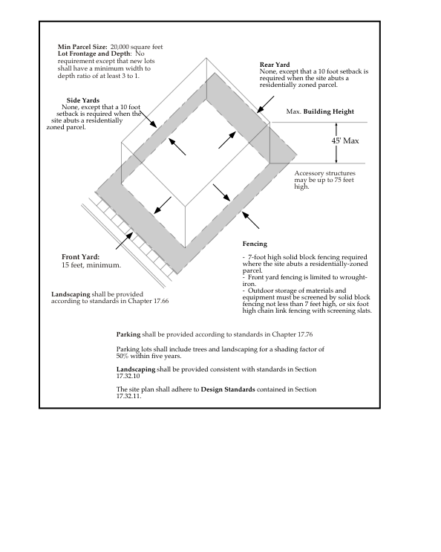

**17.32.09 Signs**

Signs shall be consistent with the requirements detailed in Chapter 17.69 Signs.

**17.32.10 Landscaping**

A. A landscaping and irrigation plan shall be submitted to the City Planner for review and approval. If the landscaping area exceeds 2,500 square feet, the landscaping and irrigation plan shall comply with the regulations contained in Chapter 17.66 Landscaping, Irrigation and Grading.

B. The landscaping and irrigation plan shall show a tree-planting scheme in the parking lot that will result in 50 percent of the parking lot being shaded within five years.

C. The landscaping and irrigation plan shall provide for a minimal amount of turf and shall incorporate a variety of xerophytic plants, mulch to reduce water use, and an automated irrigation system that incorporates water conservation technology, including drip irrigation, smart irrigation controllers, and low-flow irrigation heads.

D. All trash enclosures shall be surrounded by a 6-foot solid block wall and shall be covered by a trellis system. The area around the enclosure shall be landscaped. The gate to the enclosure shall be constructed of metal.

**17.32.11 Design Standards**

A. All metal buildings shall be designed with a front facade that is composed of a material other than metal, including stucco, brick, rock or wood. The front facade of these buildings shall contain a recognizable bulkhead, cornice and combination of window and door openings. These openings can be accented with awnings.

B. All front yard fencing shall be wrought-iron or wrought-iron with columns composed of brick, stucco, concrete or some combination thereof.

C. Parking aisles should be separate from loading and unloading routes to improve vehicular circulation.

D. Common driveways to industrial sites that have multiple tenants are encouraged.

E. Parking lot driveways should be located as far as possible from street intersections. The number of access points onto a public roadway should be kept to a minimum.

F. A buffer area shall be established between public roadways and parking lots and loading and unloading zones. This area shall be landscaped and provided with an automated irrigation system. Low walls and decorative fencing may be installed in this area.

G. Parking lots shall be designed so that solid waste pick-up can be accommodated without requiring excessive backing up by solid waste trucks.

H. Loading facilities should be located out of view of the public right-of-way. Loading docks are most appropriately located at the rear of buildings. Public roadways shall not be used during the loading and unloading of materials or goods.

I. All roof-mounted equipment shall be screened from public view.

J. New development should be designed with a precise concept for signage, including provisions for sign placement, scale, and sign readability. The design of individual signs should be integrated with building architecture, in terms of materials, colors and texture.

K. Exterior lighting to provide illumination for the security and safety of on-site areas such as parking, loading, shipping and receiving, and other work areas is encouraged

L. Exterior lighting shall be designed and directed to only illuminate the subject site.

**17.32.12 Performance Standards**

A. In the I district, all open and unlandscaped portions of any lot shall be maintained in good condition, free from weeds, dust, trash and debris.

B. No use shall be permitted and no process, equipment, or materials shall be employed which are found by the Planning Commission to be injurious to persons residing or working in the vicinity by reason of odor, fumes, dust, smoke, cinders, dirt, refuse, noise, vibrations, illumination, glare or heavy truck traffic, or to involve any hazard of fire, explosion, or to emit electrical disturbances which adversely affect commercial or electronic equipment outside the boundaries of the site.

C. No solid or liquid wastes shall be discharged into a public or private sewage disposal system except in compliance with the regulations of the owners of the system, and local, state and federal agencies that regulate disposal of these wastes.

D. In the I district, all uses shall be subject to the regulations of local, state and federal air quality agencies.