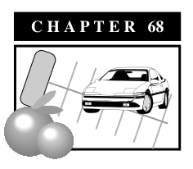

**Parking and Loading**

**Sections**

**17.68.01 Purpose**

**17.68.02 General Requirements**

**17.68.03 Number of Parking Spaces Required**

**17.68.04 Parking Lot Design Standards and Location Criteria**

**17.68.01 Purpose**

The purpose of this chapter is to provide parking and loading regulations for new, and the expansion of existing, development and uses in Exeter. This chapter will also serve to: provide accessible, attractive, secure, and well maintained parking and off-street loading facilities; provide parking and loading facilities that are designed to reduce traffic congestion; minimize the impact of new development on parking and loading facilities on surrounding properties; ensure the maneuverability of emergency vehicles in parking facilities and provide for loading and delivery services in proportion to the needs generated by the proposed land use which are clearly compatible with adjacent parcels and the surrounding neighborhood.

**17.68.02 General Requirements**

A. No building shall be constructed or use permitted unless off-street parking and loading spaces are provided in accordance with the provisions of this chapter unless otherwise exempted by this chapter.

B. When an existing use or building is enlarged and requires additional parking and loading under the provisions of this chapter, said improvements shall be provided on the subject site or the developer shall provide an in lieu parking fee consistent with the provisions in this chapter.

C. For uses not listed in this chapter, the Planning Director shall determine parking and loading standard for the use based on the operational, size and locational characteristics of the use and the standards that similar cities apply to said use.

D. Fractional space requirements shall be rounded up when the fractional number is 0.5 or more and shall be rounded down when the fractional number is less than 0.5.

E. In any residential district, all inoperable motor vehicles shall be stored in a garage, carport or outside the front yard setback area of a residential district.

**17.68.03 Number of Parking Spaces Required**

The minimum number of parking spaces (or stalls) required for new uses or buildings or the expansion of existing buildings or uses are detailed below. The abbreviations used below are as follows: s.f. = square feet, gfa= gross floor area and nfa=net floor area.

A. Residential uses

a. Single family residence: two covered stalls per unit

b. Second residential unit: one uncovered stall per unit

c. Condominium unit

1. One bedroom: one covered stall per unit

2. Two or more bedrooms: two covered stalls per unit

d. Specialized housing

1. Emergency shelters: one stall for every four beds

2. Group care housing: two stalls for every two clients; tandem parking is permitted.

3. Transitional housing: one stall for every three clients.

4. Supportive housing: one stall for every three clients.

5. Labor camps: one stall per living unit

6. Nursing homes: one stall for every three beds

7. Family and group day care homes: one stall for every three beds

e. Multiple family units: 1.5 stalls per units half of which shall be covered

f. Senior housing: one covered stall per unit

g. Mobile home parks: two covered stall per unit; tandem parking permitted

h. Trailer parks: one stall per trailer pad

i. Motels and hotels: one stall per room.

j. Convalescent home: one stall per three beds

k. Retirement homes



B. Office Uses

a. Medical and dental offices: one stall per 250 sq. ft. of building area

b. Medical and dental clinics: one stall per 200 sq. ft. of building area

c. Professional offices, including insurance, specialized consultants, law, travel, real estate, accountants, financial advisors and architects: one stall per 250 sq. ft. of building area

d. Other offices: one stall per 250 sq. ft. of building area

C. Personal Services

a. Banks, savings and loan, check cashing, credit unions, and Western Union offices: one stall per 200 sq. ft. of building area

b. Self-service laundry: one stall for every three machines

c. Barber/beauty shops, day spas, massage therapists and hair stylists: two stalls per station

d. Funeral home, mortuaries: one stall for every 50 sq. ft. of building area

Store.PDFD. General Commercial Uses.

a. Retail stores including clothing, shoes, stationary, sporting goods, kitchen wares, gift shops, book stores and beauty supplies: one stall per 350 sq.ft. of building area

b. Convenience stores: one stall per 200 sq. ft. of building area

c. Furniture, hardware and appliance stores: one stall per 600 sq. ft. of building area

d. Grocery stores: one stall per 300 sq. ft. of building area

e. Antique and second-hand shops: one stall per 350 sq. ft. of building area

f. Auto parts: one stall per 500 sq. ft. of building area

E. Eating and Drinking Establishments

Restaurant.PDF1. Coffee and tea establishments, candy shops and bakeries:one stall per 100 square feet of building area

2. Restaurants: one stall per four seats

3. Fast food establishments: one stall per 100 sq. ft. of building area

4. Donut shops: one stall per 100 square feet of building area

5. Sandwich shops and delicatessens: one stall per 100 square feet of building area.

6. Sports bars: One stall per three seats

7. Bars: one stall per three seats

Car.PDFF. Service Commercial Establishments

1. Tire, brake, radiator, and auto repair shops: one stall per 200 square feet of building area.

2. Multi-tenant auto-related shops: one stall per 200 square feet of building area.

3. Full-service car washes: one stall per 200 sq. ft. of building area

4. Self-service car washes: one parking stall per bay

5. New/Used-car sales: one parking stall per employee plus one stall for every 20 cars displayed on the sales lot.

6. Oil change shops: one stall per bay

7. Service stations: one stall per 300 sq. ft. of building area.

8. Auto glass, upholstery and stereo shops: one stall per 200 sq. ft. of building area

9. Paint and body shop: one stall per 200 square feet of building area.

10. Wholesale establishments: one stall per 600 sq. ft. of building area.



G. Recreation Uses

1. Health clubs: one stall per 100 sq. ft. of building area

2. Bowling alleys: one stall per 100 sq. ft. of building area.

3. Dance and martial arts studios: one stall per 100 sq. ft. of building area

4. Golf courses: 1.5 stall per tee plus one stall for every four seats

6. Stadiums, arenas, and other outdoor facilities: one stall for every five seats

7. Video arcades: one stall per 100 sq. ft. of building area

8. Rodeo and equestrian facilities: one stall for every five seats

9. Miniature golf course: 1.5 stalls per tee

H. Miscellaneous Commercial

1. Retail nursery/garden shops: one stall for every 1,000 sq. ft. of outdoor display area

2. Agricultural Chemicals/Sales: one stall per 500 sq. ft. of building area

3. Agricultural Services, including topping, farming operations, trucking, farm maintenance, spraying, agricultural contractors, and contract farming: one stall per 500 sq. ft. of building area

4. Farm machinery, sales and service: one stall per 500 sq. ft. of building area



I. Industrial Uses

1. Manufacturing: one stall per 500 sq. ft. of building area

2. Fabrication: one stall per 500 sq. ft. of building area

3. Mini-storage: two stalls plus one stall for every 250 sq. ft. of building area

4. Warehousing: one stall per 1,000 sq. ft. of building area

5. Packing house: one stall per 750 sq. ft. of building area

6. Food productions and processing: one stall per 500 sq. ft. of building area

Church.PDF

J. Institutional Uses.

1. Churches: one stall per four seats

2. Schools

a. Nursery and pre-schools: one stall per classroom plus one stall for every 250 sq. ft. of nonclassroom building area

b. Elementary and middle schools: one stall per classroom plus one stall per 500 sq. ft. of building area.

c. High schools: three stalls for every two staff members

d. Business and trade schools: three stalls for every two staff members

3. Libraries, museums and art galleries: one stall per 500 sq. ft. of building area

4. Hospitals: one stall per bed

5. Medical clinics: one stall for every 200 sq. ft. of building area

K. Government

1. Governmental centers: one stall per 400 sq. ft. of building area

2. Courthouses: one stall per 400 sq. ft. of building area

3. Public safety buildings: one stall per 400 sq. ft. of building area

4. Corporation, transportation and fuel yards: one stall per 500 sq. ft. of building area

5. Wastewater treatment facilities: one stall per 400 sq. ft of building area

6. Water treatment facilities: one stall per 400 sq. ft. of building area

**17.68.04 Parking Lot Design Standards and Location Criteria**

A. Design Dimensions

Parking lots shall be designed to be consistent with the standards, dimensions and requirements of the details contained in Exhibit 68-1. The construction of parking lots shall be consistent with the improvements standards contained in Exeter’s Improvements Manual.

**Exhibit 68-1: Parking Design**

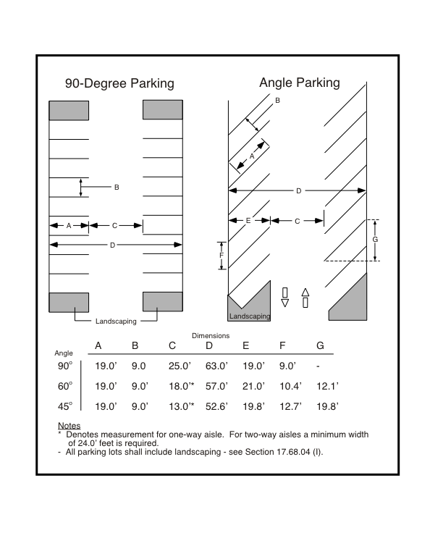

B. Circulation

Parking lots shall be designed so that a travel lane within a parking lot has a minimum width of 12 feet, the backup distance for a car backing out of a stall has a minimum distance of 27 feet, and that backing into a public street from a parking stall shall be minimized in order to maintain effective traffic flow along the public street. Single-family dwellings will be exempt from this requirement. The use of alleys to access parking lots shall be encouraged.

C. Paving, Slope and Drainage

All parking lots shall be constructed with a 4-inch aggregate base and a 2-inch asphalt or concrete overlay, described in the Exeter Improvements Manual. Parking lots shall be sloped so that storm water runoff flows towards public streets or alleys, into on-site landscape planters or bioswales or into pervious hardscape features.

D. Curbing and Wheel Stops

Concrete curbing shall be provided around all parking lots and landscape planters consistent with the Exeter Improvements Manual. Wheel stops may be provided in parking stalls to ensure that the overhang of a vehicle does not interfere with pedestrian movements along a sidewalk, or damage landscaping adjacent to the parking lot.

F. Stripping and Symbols

Parking lot stalls and travel lanes shall be clearly marked with painted strips. Parking stalls for handicapped persons shall be stripped and provided with the appropriate symbols and signage that are consistent with the American Disabilities Act (see Exhibit 68-2).

**Exhibit 68-2: *Striping and Handicap Space Design Standards***

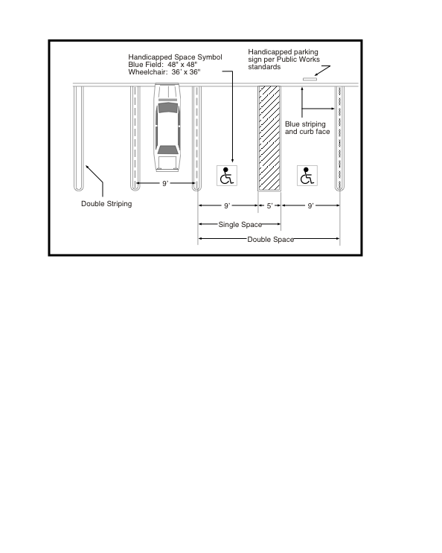

G. Lighting

All parking lots shall have pole lighting that property illuminates the parking lot but does not cause a nuisance for adjoining properties.

H. Driveways

Driveways from a public street or alley shall have locations and dimensions consistent with the Exeter Improvements Manual. For one-way driveways the width of the driveway shall be 15 feet; two-way driveways shall have a minimum width of 25 feet.

I. Landscaping (see also Exhibit 68-3)

All parking lots shall be landscaped in accordance with the requirements in Chapter 17.66 Landscaping, Irrigation and Grading. Trees shall be planted within all parking lots. Tree species shall be selected that will not cause damage to the parking lot or adjacent sidewalks, driveways or curbing, and will shade more than 50 percent of the parking lot within ten years. Landscape planters between the parking lots and public streets shall be planted with low hedges. As an alternative, a low wall (three feet) may be constructed and shrubs, turf or ground cover may be planted between the wall and the street.

**Exhibit 68-3: *Typical Parking Lot Landscaping Scheme***

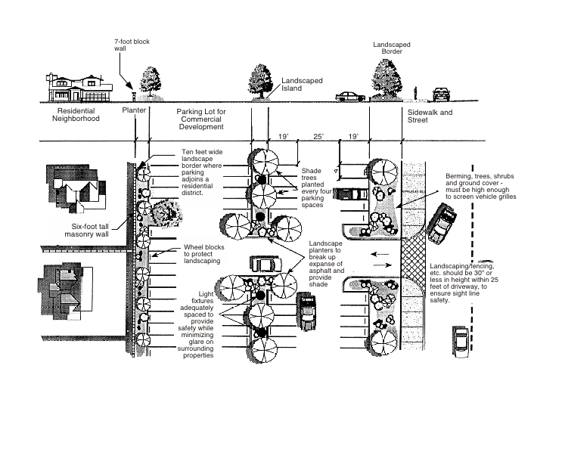

J. Location Criteria

Parking lots shall be located on the same property as the building they serve, except that parking for buildings in the Central Commercial (CC) district may be located within 300 feet of the subject property. In the CC district, parking lots shall be located at the rear or side of the subject building. Parking lots shall not be located on the corner where two streets intersect.

K. Shared Parking

Where two or more non-residential uses share a single parking lot, the number of required parking spaces may be reduced by a maximum of 20 percent, as long as the total number of spaces is not less than the required for the use requiring the largest number of spaces.

Where non-residential uses share a single parking lot and it can be demonstrated that the uses operate at different times of the day (an evening use versus a day-time use), the required number of parking spaces may be reduced by up to 50 percent of the combined parking requirements of the two uses.

L. Parking Standard Modifications

Parking space requirements may be modified through Exeter’s minor deviation process. The Planning Director may approve a reduction of up to 20 percent in a project’s required parking spaces if the following findings can be made:

1. That the granting of the minor deviation will not create a safety hazard or lead to a condition where the loading of public vehicles onto public streets will interfere with the free flow of traffic on these streets.

2. That the granting of the minor deviation will not create a safety hazard of any other condition inconsistent with the objectives of the Zoning Ordinance.

M. Handicapped Parking Spaces

Handicapped parking stalls shall be provided per the Uniform Building Code. Handicapped parking stalls shall be designed consistent with the illustrations shown in Exhibit 68-2.

N. Loading Facilities

1. Commercial, industrial, office, institutional, and public uses exceeding 10,000 square feet in size shall be required to install an off-street loading facility unless the Planning Director finds that due to the operational nature of the use, none or more than one off-street loading space should be required.

2. To the extent possible, loading facilities should be located at the rear or side of the building that they are to serve.

3. Streets and alleys shall not be used as loading or unloading areas, nor shall trucks use streets and alleys for maneuvering trailers into a loading space.

4. Loading facilities, at a minimum, shall have a length of 25 feet, a width of 12 feet, and an overhead clearance of 14 feet. All loading surfaces shall be paved consistent with Exeter’s Improvements Manual.

5. Where a loading facility is near or adjacent to a residential district or other noise-sensitive land uses, noise attenuating design measures will be incorporated into the project. These design measures could include increased setback distances, the construction of a 7-foot solid block wall, landscaping or locating the loading facilities away from noise-sensitive land uses.

6. All loading facilities shall be lighted to provide adequate illumination of the loading area for safety and security reasons. Where a loading area is near or adjacent to a residential district or other light-sensitive uses, the lighting shall be directed away from these uses.