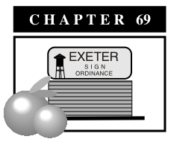

**Signs**

**17.69.01 Purpose**

**17.69.02 Definitions**

**17.69.03 Applicability**

**17.69.04 Standards by Zone District**

**17.69.05 Miscellaneous Signs**

**17.69.06 Design Criteria**

**17.69.07 Prohibited Signs and Locations**

**17.69.08 Exempted Signs**

**17.69.09 Murals**

**17.69.10 Non-Conforming Signs**

**17.69.11 Administration**

**17.69.12 Minor Deviations**

**17.69.01 Purpose**

The purpose of this chapter is to establish procedures for regulating signs, including the type, size, and location and construction standards of signs by zone district. Signs have an obvious impact on the character and quality of the city. As a prominent part of the visual environment, they attract or repel the viewing public, affect the safety of vehicular traffic and their suitability or appropriateness helps to set the tone of the neighborhood. The objectives of this chapter include the following:

A. To reinforce that the sign should serve primarily to identify the general nature of an establishment or to direct attention to a project, activity, place, person, organization, or enterprise.

B. As identification devices, signs must not subject the citizens of the Exeter to excessive competition for their visual attention. As appropriate identification devices, signs must harmonize with the building, the neighborhood, and other signs in the area.

C. The City of Exeter intends to encourage the installation of signs that improve the appearance of the property and the neighborhood and to enhance the economic effectiveness of signs.

D. The provisions in this chapter provide standards to safeguard life, health, property, and public welfare in keeping with the character of the City of Exeter by regulating the size, height, structural design, quality of materials, construction location, electrification, illumination and maintenance of all types of signs and sign structures.

E. The provisions in this section present criteria indicating whether or not signs conform to the above intentions of suitability and safety.

**17.69.02 Definitions**

As used in this chapter, the following items are defined in this section. Some terms are illustrated in Exhibits 69-1 and 69-2.

A. “A-Frame Sign”. See “Sandwich Board Sign”.

B. “Advertising Structure” means any notice or advertisement, pictorial or otherwise, and all such structures used as an outdoor display, including billboards, regardless of size and shape, for the purposes of making anything known, the origin or place of sale of which is not on the property with such advertising structure.

C. “Aggregate Area” means the total area of all permanent signs on the premises.

D. “Alley-Side Sign” means a sign placed on the wall of a building that faces onto or abuts a public alley.

D. “Animated Sign” means a sign with action or motion, whether by flashing lights, color changes, wind, rotation, movement of any parts of the sign or letters or parts of the sign structure, or other motion.

E. “Awning Sign” means a sign applied to an awning or canopy that is attached to a building.

F. “Banner” means any cloth, bunting, plastic, paper, or similar material attached to, or appended on or from any structure, staff, pole, line, or framing upon which there is an advertising message.

G. “Changeable copy sign” means a sign or portion thereof with characters, letters, or illustrations that can be changed or rearranged without altering the face or the surface of the sign. A sign on which the only copy that changes is an electronic or mechanical indication of time or temperature shall be considered a “time and temperature” sign and not a changeable copy sign for purposes of this chapter.

H. “Copy” means any graphic, letter, numeral, symbol, insignia, text, sample, model, device, or combination thereof that relates to advertising, identification, or notification.

**Exhibit 69-1: Selected Sign Definitions**

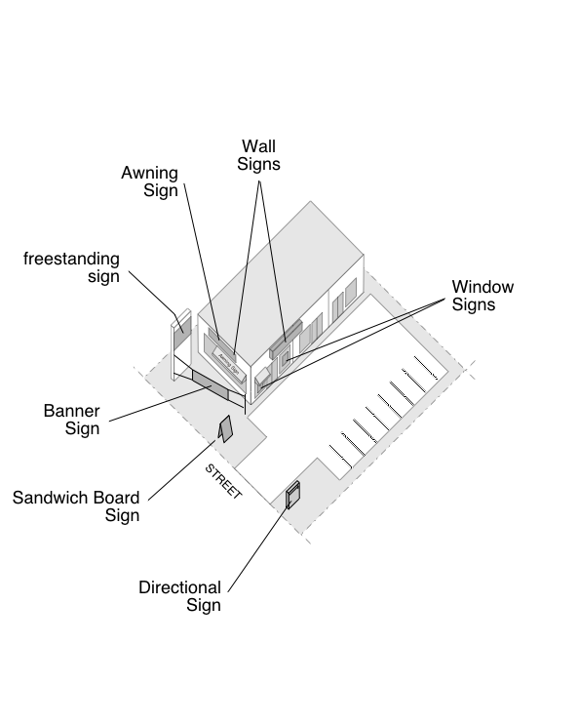

I. “Directional Sign” means signs giving only information and direction to the viewer and containing no advertising message.

J. “Directory Sign” means a sign typically used to list individual businesses in a multi-tenant complex or center.

K. “Externally illuminated sign” means a sign that has light cast on its surface from an artificial exterior source installed for the purpose of illuminating the sign.

L. “Freestanding Sign” means a sign, which is supported by one or more columns, uprights, or braces in or upon the ground.

M. “Internally illuminated sign” means any sign whose illumination originates from within the structure of the sign and the source of which is not visible from the exterior of the sign.

N. “Nonconforming Sign” means any sign, which was lawfully erected or maintained prior to the time of adoption of this title.

O. “Occupancy Frontage” means a single lineal dimension measured horizontally along the front of a building, which defines the limits of a particular occupancy at, that location and which has direct pedestrian access through an exterior wall which is visible from the public right of way.

P. “Off-premises signs and billboards” means any sign not located on the same lot or project site as the use, product, or service it advertises.

Q. "Roof line" means the highest point of a parapet wall or the main roof structure or a highest point of a parapet wall other than such architectural features as cupolas, pylons, projections or minor raised portions of the roof.

R. "Pedestrian oriented sign" means a sign that is specifically located and designed to be viewed from a pedestrian right-of-way.

S. “Pennant” means series of lightweight plastic, fabric, or other materials, suspended from a rope, wire, or string designed to move in the wind. Pennants shall not include banners as defined in this chapter or individual flags mounted on a single pole.

T. "Political sign" means a sign advertising a candidate for political office, a political party or a measure scheduled for an election.

U. "Portable sign" means a sign that is capable of being carried or moved by manual or mechanical means from one location to another and which is not affixed to the ground, a structure, or a vehicle.

V. “Projecting Sign” shall mean a sign that projects from and is supported by a wall or a façade of a building and are also referred to as marquee signs.

W. "Reader board" means a sign indicating the name, address and type of business of the businesses within a building.

X. “Roof Sign” means a sign erected upon or above a roof or parapet of a building.

Y. “Sandwich Board Sign” means a portable sign with advertising messages mounted on two surfaces with two edges connected and the other two edges spread so that the two faces read from different directions.

Z. "Sign" means any words or symbols used for visual communication including its structure and component parts intended to be used to attract attention to an activity. "Sign area" means the geometric area of a sign including all elements such as board or frames, perforated or a solid background, ornamental embellishments, arrows or other sign media. The area of individual signs shall be measured as follows (see also Exhibit 69-2):

1. Sign Faces Counted: Where a sign has two faces containing sign copy, which are oriented back to back and separated by not more than twenty-four inches at any point, the area of the sign shall be measured using one sign face only.

2. Wall Mounted Letters: Where a sign is composed of letters individually mounted or painted on a building wall, without a border or decorative enclosure, the sign area is that of the smallest area of a rectangle within which all letters and words can be enclosed.

3. Three-Dimensional Signs: Where a sign consists of one or more three-dimensional objects such as balls, cubes, clusters of objects, or sculptural or statute-type trademarks, the sign area shall be measured as the area of the smallest rectangle within which the object(s) can be enclosed, when viewed from a point where the largest area of the object(s) can be seen.

**Exhibit 69-2: Sign Area Measurement**

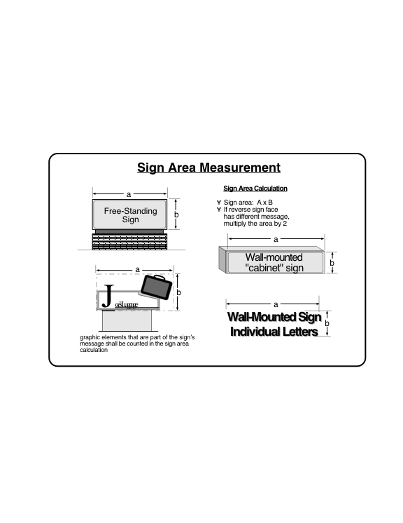

AA. "Sign copy" means any words, letters, numbers, figures, designs, or other symbolic representations incorporated into a sign face and/or its structure with the purpose of attracting attention to the subject matter.

BB. "Sign face" means the panel surface of a sign that carries the advertising or identification message.

CC. "Sign structure" means any structure that supports or is capable of supporting any sign. A sign structure may or may not be an integral part of a building. For the purpose of a freestanding sign, the sign structure shall include the aggregate area of the sign including the sign copy and all structural elements of the sign.

DD. "Site" means the length of a site along the street or other principal public thoroughfare, but not including such a length along an alley, watercourse, railroad or freeway.

EE. “Special events sign” means any sign advertising specific temporary events, such as carnivals, festivals, exhibits, and parades, but not including promotional sales or grand opening signs.

FF. “Temporary sign” means a sign designed to be used for short periods of time, as opposed to a permanently mounted sign such as a freestanding sign or wall sign.

GG. "Temporary subdivision sign" means a sign erected and maintained within the boundaries of a recorded subdivision and indicating the name of the subdivision, the name of the contractor and/or subdivider, the name of the owner and/or agent, and giving information regarding directions, price or terms concerning the sale or lease of parcels within the subdivision.

HH. “Wall Sign” means a sign attached to or erected against the wall or façade of a building or structure with the exposed face of the sign in a plane parallel to the plane of the wall or façade.

II. “Window Sign” means a sign mounted within or on a window.

**17.69.03 Applicability**

No sign shall be erected, placed, established, painted, created, or maintained in the city that is not in conformance with the standards, procedures, and other requirements of these provisions. All signs erected within the Exeter city limits shall be subject to the sign application procedures within these provisions. The regulations in this chapter are in addition to those set forth in the California Building Code, the California Electrical Code and the 1997 Uniform Sign Code, as adopted, and any amendments made thereto by the city, and the nuisance provisions in the Exeter Municipal Code.

**17.69.04 Standards by Zone Districts**

Signs permitted by zone district are listed as follows

A. Residential (RA, R-1, R-M), Urban Reserve (UR), Open Space (O), Agriculture (A) and Public Facilities (PF) zone districts.

B. Unlighted signs and other commercial advertising shall be permitted in residential districts only as provided in this section.

1. Name plates shall be permitted subject to the following conditions.

a. Maximum size: two square feet

b. Content: Name plates may display the following: name of the premises upon which it is displayed; name of the owner or lessee of the premises; address of the premises; nature of a home occupation engaged in on the premises; and private information such as “beware of dog” or “no solicitors”, that does not contain an advertising message.

c. Placement: Nameplates shall be affixed flush to the subject building

2. “For Rent” and “For Sale” signs shall be permitted. Not more than two such signs, not exceeding a total of six square feet (aggregate) in area, shall be permitted on any lot or parcel.

3. For subdivisions, apartment complexes and mobile home parks, churches and other permitted institutional uses; no more than one sign shall be erected at any entrance to the development. Signs shall not exceed 35 square feet for all readable surfaces, nor exceed four feet in height.

C. Commercial and Industrial Zone Districts (CN, CS, CC, CH and I))

The following signs are permitted for each business in commercial and industrial districts (see also Exhibit 69-3 for graphic illustration of standards for various sign types). For multi-tenant shopping centers or office parks containing three or more individual uses, the Planning Director shall submit a coordinated sign program for review and approval.

1. The number of wall signs permitted per business or parcel is as follows:

a. One primary wall sign is permitted on the wall with the primary public entrance to the business. For businesses with more than one entrance, only one entrance shall be counted as the primary entrance.

b. Where the site abuts a public street and the primary wall sign is on a wall not facing the street, a secondary wall sign is permitted on the wall facing the street.

c. If the site has a parking lot and a building wall faces the parking lot and that wall does not have a wall sign permitted under a. or b, above, a secondary wall sign is permitted on the wall facing the parking lot. Not more than one such parking lot sign is permitted.

d. For businesses fronting onto a public alley, one alley wall sign is permitted for the wall that faces onto the alley.

**Exhibit 69-3: *Selected Sign Standards***

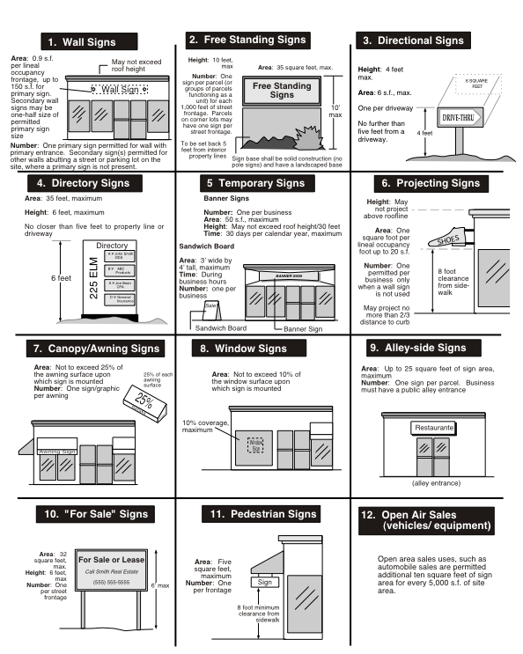

2. Calculation of Wall Sign Area:

a. For a primary wall sign, 0.9 square foot of sign area is permitted for each foot of linear occupancy frontage, as shown in Exhibit 69-4, up to a maximum of 150 square feet of sign area, whichever is less. Notwithstanding this regulation, all businesses shall be permitted a minimum of 25 square feet of primary wall sign.

b. Where a secondary wall sign is permitted, the maximum sign area shall be one-half the permitted sign area of a primary sign.

c. For an alley wall sign, the maximum sign area shall be 25 square feet.

d. For multi-tenant buildings, each tenant shall be permitted one sign mounted on the wall with the primary entrance, except for corner units that may be permitted a primary wall sign and a secondary wall sign.

3. Maximum Height: Not to exceed the top of the vertical wall surface on which the sign is mounted. Signs mounted on a pitched roof may not extend the peak of the ridgeline of the roof. No sign is permitted on the top of a flat-roofed structure.

4. Permit. A sign permit shall be obtained for all wall signs, consistent with the procedure outlined in Section 17.69.110 of this Section.

**Exhibit 69-4: *Permitted Wall Sign Area***

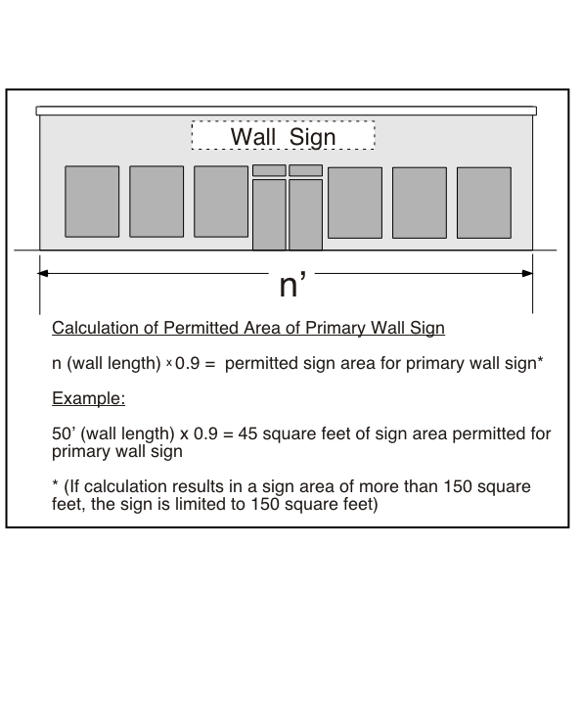

2. Free-Standing Signs

a. Maximum Height: Ten feet

b. Maximum Area: 35 square feet per sign face

c. Sign Design: Free standing signs shall be designed as a monument sign with a solid base extending the entire height of the sign.

d. Number per parcel: One free-standing sign is permitted per parcel (or collection of parcels functioning as a single integrated development) for each 1,000 feet of street frontage, or fraction thereof, except that parcels with frontage on more than one public street shall be permitted one free-standing sign for each 1,000 lineal feet of frontage (or fraction thereof) on each street

e. Setbacks: A free standing sign shall be set back a minimum of 5 feet from any interior side property line. The Planning Director may permit encroachment into a setback where the location of existing improvements presents a functional hardship in compliance with the required setback.

f. Landscaping. All freestanding signs shall be surrounded by landscaping of an area at least twice the size of one side of the sign structure.

g. Permit. A sign permit shall be obtained for all freestanding signs, consistent with the procedure outlined in Section 17.69.110 of this chapter.

3. Directional Signs

a. Maximum height: 4 feet

b. Maximum Area: 6 square feet

c. Number per site: one per driveway from a public street

d. Location: Directional signs shall be placed within five feet of a driveway that accesses the site from a public street. Placement of directional signs shall ensure the sight safety of vehicles entering/leaving a site is not compromised.

e. Permit. A sign permit shall be obtained for all directional signs, consistent with the procedure outlined in Section 17.69.110 of this chapter.

4. Directory Signs

a. Number per site: one per public vehicle and/or pedestrian entrance to the site

b. Maximum Area: 35 square feet.

c. Maximum Height (if freestanding): 6 feet.

d. Location: No directory sign which is a freestanding sign may locate closer than 5 feet to any neighboring property line or closer than three feet to any point of ingress/egress.

e. Permit. A sign permit shall be obtained for all directory signs, consistent with the procedure outlined in Section 17.69.110 of this chapter.

5. Temporary/Portable Signs

a. Banners

i. Number of signs: One banner sign is permitted per business.

ii. Maximum Height: Not to exceed roofline of nearest building or building affixed to but in no case higher than 30 feet. Banner signs shall not be attached to existing freestanding signs.

iii. Maximum Area: 50 square feet

iv. Permitted Time: Banner signs may not be utilized for more than 30 days per calendar year. The banner shall include a date visibly noted on the sign and be removed within 30 days of the posted date.

v. Temporary signs used to identify a business shall be removed within thirty days and replaced with a permanent sign.

vi. Permit. A sign permit shall be obtained for all banner signs, consistent with the procedure outlined in Section 17.69.110 of this chapter.

b. Sandwich Board Signs

i. Maximum Height and Width: Three feet wide and four feet tall, maximum

ii. Maximum Area: 12 square feet

iii. Number per business: One

iv. Location: May be placed on the business site as long as conflicts with vehicle safety are not caused. May also be placed on the public sidewalk adjacent to the business with approved encroachment permit, but must permit a minimum of five feet of passage area on sidewalk.

v. Permitted Display Time: During business hours.

c. Changeable message signs. A business that enters into an agreement with the City to not use temporary signs may be permitted a changeable message sign to be incorporated into its free-standing monument sign, or as a building wall sign, provided that the overall sign area for the business is not increased (see Exhibit 69-4).

6. Projecting Signs

a. Maximum Height and Projection: Not to exceed roofline of wall or structure to which projecting sign is attached. (Note: Bottom of sign shall be a minimum of 8 feet from ground to provide proper clearance).

b. Number per business: One, but a projecting sign is permitted only where a wall sign is not used on the same wall.

c. Calculation of Area: 0.5 square foot of sign area for each lineal foot of building frontage of the business to which sign pertains

d. Maximum Area: 20 square feet

e. Location: Projecting signs may extend over public rights-of-ways including public sidewalks not to exceed two-thirds of the distance from the building face to which the sign is attached to the curb face of said sidewalk

f. Permit. A sign permit shall be obtained for all projecting signs, consistent with the procedure outlined in Section 17.69.110 of this chapter.

7. Awning/Canopy Signs

a. Number of signs: Where an awning is present, a sign may be affixed to the awning.

b. Maximum Area: The area of signage on each surface of an awning shall not exceed 25 percent of the area of the individual surface.

c. Location: Awning signs shall be made of removable materials such as individual cut-out letters and/or symbols attached,

stenciled or other wise placed on the canopy surface, and may be located on exterior surfaces of a canopy. Canopy signs shall be of color, size and design to harmonize with the color, size and design of the canopy on which they are placed.

d. Permit. A sign permit shall be obtained for all canopy/awning signs consistent with the procedure outlined in Section 17.69.110 of this chapter.

8. Window Signs

Maximum Area: Up to 25% of the area of each individual window may be covered with a window sign or graphic. No permit is required for window signs.

9. Alley-Side Signs

a. Number of Signs/Sign Area: Any building facing a public alley shall be permitted one alley-side sign with a maximum of 25 square feet of sign area. An alley-side sign may be in the form of either a wall-sign, awning sign, or projecting sign.

b. Height. Alley side signs may not project above the wall on which they are mounted.

c. Permit: A sign permit shall be obtained for all alley-side signs consistent with the procedure outlined in Section 17.69.110 of this chapter.

10. "For Sale", "For Rent", or similar signs

a. Number of signs: One sign shall be permitted per street frontage.

b. Size: 32 square feet per sign.

c. Height: maximum of 6 feet.

d. Permit: None required.

11. Pedestrian Signs

a. Number of signs: One pedestrian oriented sign that projects or hangs above a sidewalk on each side of a building with a public entrance.

b. Size: Each sign may be a maximum of 5 square feet in size and may hang or be suspended no lower than eight feet above grade level.

12. Service Station Canopy Signs

a. Number of signs: One sign is permitted on each canopy face.

b. Size: Ten square feet, maximum per canopy face

c. Design: Additional graphic elements, such as color stripes associated with the particular brand shall not be permitted on service station canopies.

d. Permit: A sign permit shall be obtained for all service station canopy signs, consistent with the procedure outlined in Section 17.69.110 of this chapter.

13. Incidental traffic control signage in parking lots within private developments

a. Number of signs and size: As determined to be necessary by the City Engineer

14. Special Uses Standards

a. Open Air Sales

In addition to the sign area permitted under this section, ten square feet of additional sign area is permitted for every 5,000 square feet of site area for vehicle and large equipment sales operations. The additional signage may be used to increase the allowable area for wall signs and freestanding signs, except that height shall not be increased for freestanding signs.

b. Drive-through menu boards

No more than two drive-through menu/order boards are permitted for each food and/or beverage establishment featuring a drive-through. Each sign shall not exceed 40 square feet and be no taller than 8 feet.

**17.69.050 Miscellaneous Signs**

A. Construction Project Signs

Construction project signs shall not exceed 32 square feet in area, and 8 feet in overall height, unless legally required by governmental contract to be larger. One sign is permitted for each street upon which the construction site fronts. A Construction Project Sign shall not require a sign permit and may exist no longer than the period of construction.

B. Subdivision Advertising Signs

1. Time of Placement: Subdivision signs may require a sign permit and shall be permitted as long as some portion of the property advertised for sale remains unsold or up to two years in duration, whichever is less.

2. Location: Subdivision signs may only be located on the premises that they advertise.

3. Size and Number of Signs: No individual sign may exceed 120 square feet of area and be no taller than ten feet. No more than four separate signs are permitted on the grounds of each subdivision.

4. Model Home Lots: Signs are permitted on the same lot with a model home provided they do not exceed four in number and ten square feet each in area. Signs shall be removed after the developer concludes the initial sale of the lots or homes to their initial owners.

5. Permit: A sign permit shall be obtained for all subdivision signs, consistent with the procedure outlined in Section 17.69.110 of this chapter.

**17.69.060 Design Criteria (see Exhibit 69-5 for illustrations of selected criteria)**

A. Design Compatibility: The design of all signs shall be compatible and harmonious with the colors, materials and architecture of the building and the immediate vicinity. Freestanding signs shall be finished with the same or compatible materials as the building on the site.

B. Size: Notwithstanding applicable sign standards elsewhere in this chapter, sign size shall be proportionate to the size and scale of the site and building upon which the sign is proposed. Sign dimensions as specified in this chapter are maximum allowable dimensions; it may be necessary that signs be smaller than the maximum allowed in order to be proportionate in size and scale to achieve the design objectives of this section.

C. Commercial and Industrial Center Signs: Individual tenant signs within multi-tenant centers shall be coordinated in size, location, materials and illumination.

D. Color: Colors shall be used in coordinated groupings, and shall be compatible with those colors used in the building or project design. For cabinet-style signs, a dark sign background is preferred with light colored copy (characters/graphics).

E. Logos and Trademarks: this section shall not prohibit the use of established corporate colors or logos. When established corporate colors are incompatible with buildings colors, compatibility in design with the surrounding development should be accomplished through the use of appropriate background colors or other design features.

F. Lighting Intensity: The light emitted or reflected by a sign, or emitted by a light source, shall be of reasonable intensity and shall be compatible with the architecture of the building and the immediate vicinity. Artificial light sources shall be shielded to prevent light spillage, glare or annoyance to persons on or inside adjoining properties or to public or private rights-of-way.

G. Sign Bases and Frames: Freestanding signs shall be either housed in a frame, or set onto a base, presenting a solid, attractive, and well-proportioned appearance. The size and shape of the frame or base shall be proportionate to the size and mass of the sign and should be low-profile in design. Pole type signs are not permitted. Guy wires, angle irons, braces and other support or construction elements shall be screened or hidden from view.

H. Landscaping: Freestanding signs shall be located in a landscaped area proportionate to the size of the sign, but not less than twice the size of one side of the sign face. Appropriate accent landscaping should be placed at the base of the sign.

**Exhibit** **69-5: *Selected Sign Design Criteria***

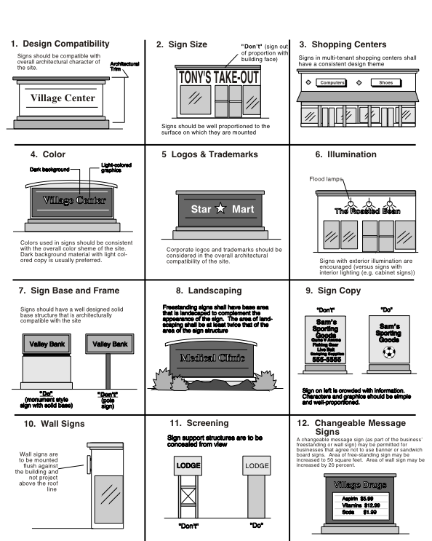

I. Sign Copy: Sign copy should be simple and concise without excessive description of services or products. On freestanding signs, sign copy should be designed to contribute to the design of the structure on which it is displayed. In all cases, freestanding sign design and sign copy should be coordinated to provide an attractively designed freestanding element which identities the development or project.

J. Wall Signs: Building signs should be mounted flush against the building, and shall not project above the roof ridge or the top of the parapet.

K. Maintenance: All signs and their supporting members shall be kept in good repair and maintained in good structural condition at all times.

L. Design Quality: All signs shall be professionally designed and manufactured. Signs that utilize hand-made lettering or elements should be avoided.

**17.69.07 Prohibited Signs and Locations**

A. Any sign mounted or attached to a vehicle parked for the purpose of calling attention to or advertising a special business establishment

B. Any sign or sign structure which has become a public nuisance due to inadequate maintenance, dilapidation, or abandonment

C. Any sign which obstructs in any manner the ingress to, or egress from, a door, window, fire escape, or other access way required by building codes adopted by the City of Exeter

D. Any sign unlawfully installed, erected, or maintained

E. Any sign now or hereafter existing which no longer advertises a business conducted or a product sold as prescribed in this chapter

F. Any sign that encroaches into any City right-of-way and/or easement, except an approved pedestrian, canopy, wall sign or projecting sign

G. Any sign that flashes, blinks, moves, changes color, appears to change color, changes intensity, or contains any part of attachment which does the same except that standard barber poles, time and temperature signs and approved bulletin board signs shall be permitted in commercial and industrial zones if otherwise in compliance with these provisions.

H. Any unofficial sign, signal or device, or any sign, signal or device which purports to be or is an imitation of, or resembles an official traffic sign or signal, or which attempts to direct the movement of traffic, or which hides from view any official sign or signal

I. Any lights of any color of such brilliance as to blind or impair the vision of drivers upon any roadway. Further, no light shall be placed in such a position as to prevent the driver of a vehicle from readily recognizing any traffic sign or signal

J. Any sign located so that it interferes with visibility at an intersection, public right-of-way, driveway, or other ingress/egress

K. Any sign located or displayed on or over public property except as expressly permitted by these provisions, unless approved by the City Council

L. Any sign attached to a tree

M. Any rooftop mounted sign

N. Blimps, balloons or other forms of aerial advertising

O. Any sign erected or maintained which has less horizontal or vertical clearance from communication lines and energized electrical power lines than that prescribed by the State, or rules and regulations duly promulgated by agencies thereof

P. Off-site signs, advertising structures and billboards

Q. Portable signs, other than approved banners and sandwich board signs, except for temporary signs for community events as provided for in Section 17.69.080 (G)

R. Any sign, which, in the opinion of the Zoning Administrator, is in conflict with the spirit or intent of this Chapter

**17.69.08 Exempted Signs**

The following signs and devices shall not be subject to the provisions in this chapter:

A. Signs placed by a governmental body or public utility, required to be maintained by law

B. Memorial tablets or plaques placed by recognized historical agencies

C. Flags of the National or State Government

D. Traffic or other signs of government agencies, signs required by law or contract with a governmental agency, railroad crossing signs, legal notices, and such temporary emergency or non-advertising signs as may be authorized by the City Council

E. Decorations or window signs to celebrate nationally recognized holidays and local celebrations

F. Temporary Political Signs that adhere to the following regulations

1. Political signs are permitted on lots or parcels privately owned with permission of the property owner.

2. The combined area of sign by any one candidate on any one parcel shall not exceed 32 square feet.

3. Political signs shall not be attached to trees, fence posts, or utility poles, except on private property where signs may be attached to fence posts with permission of the property owner.

4. Political signs shall not be lighted either directly or indirectly.

5. No political sign or portion thereof shall be placed in any street right-of-way or on any City-owned property.

6. No sign shall be erected in violation of street corner setback requirements that are established to ensure traffic safety, nor shall any such sign interference with pedestrian traffic.

7. Political signs shall be erected no more than 60 days prior to the date of the election.

8. All political signs shall be removed within 14 days following the date of the election. The City may remove signs not removed within this period and the cost of removal assessed against the candidate.

9. Provisions of this subsection shall not apply to political advertising on legally established existing commercial billboard structures.

G. Temporary signs placed by recognized non-profit or other community organizations advertising community events. Such signs shall be limited to 16 square feet in area and no taller than four feet. Only one such sign is permitted per parcel. Said signs shall be erected no more than 14 days before the event and shall be removed no more than seven days after the event.

**17.69.09 Murals**

It is the intent of the City Council, for purposes of promoting the local economy, tourism, and for further purposes of beautifying Exeter, to adopt standards regarding murals, their location and design.

A. Location

Murals may be located on the sides of buildings and walls on property in any commercial, industrial or public/quasi-public zone district within the City of Exeter.

B. Mural Design Approval

Prior to painting, installation and execution of a mural, an application shall be submitted to the Exeter Mural Committee. The application shall include a detailed drawing or sketch of the mural plus other details as prescribed on the application or deemed by the Committee to be pertinent. In addition, the application shall provide proof that an easement has been secured for the wall on which the mural will be applied.

The Committee shall forward the application with a recommendation to the City Council. The Council shall review and approve, approve with modifications, or deny the application as submitted.

C. Criteria for Design of Murals

1. The subject matter of the mural shall be of historical or community significance regarding the growth and development of the City of Exeter and it’s surrounding environs or be of such high quality as to be appropriate. A mural shall not contain elements that advertise an existing business or product.

2. The paint to be used shall be appropriate for use in an outdoor locale, for an artistic rendition and shall be of a permanent, long-lasting variety.

3. The mural shall be designed and painted by qualified mural artists with sufficient knowledge in the design and painting of such projects.

4. To the extent feasible, the mural shall be vandal and graffiti resistant.

**17.69.10 Non-Conforming Signs**

The lawful use of a sign existing on the effective date of this Chapter, although such use does not conform to the provisions of this chapter, may be thus continued; provided, however, a non-confirming sign which has been abandoned, or the use for which it is advertised has ceased to function for a period of 90 days or more, shall be brought into conformity with the provisions of this chapter.

A. No non-conforming sign shall in any manner (except for face changes) be structurally altered, reconstructed, or moved without being made to comply with the provisions of this chapter; however, nothing herein shall prohibit the painting, maintenance, or repairing of such sign, including the face and changing of copy.

B. If, at any time, any sign in existence or maintained on the effective date of this chapter, which does not conform to the provisions of this chapter, is destroyed by fire, accident, explosion or act of nature to the extent of more than 50 percent of the value thereof, such sign shall be subject to all the provisions of this chapter. For the purposes of this chapter, the value of any sign shall be the estimated cost of replacement of the sign in kind as determined by the Chief Building Official.

C. The Planning Director or his/her designee shall immediately cause the removal of any sign which, in the judgment of the Director is found to be within the public right-of-way and/or easements and are found to place citizens in immediate peril, by any or a combination of the following methods using sound judgment under the circumstances:

1. Removal or modification of said sign by City staff with business owner (or property owner if business has ceased operations) to be billed for time and materials.

2. Notification orally or in writing to the business owner causing the removal of said signs within a 24-hour period or lesser period of time, as prescribed by the Planning Director.

3. Immediate citation of the business owner (or property owner if business has ceased operations) or party responsible for said sign.

D. Any business that has ceased operations for at least thirty days shall remove all temporary signs and all window signs.

**17.69.11 Administration**

Except for where otherwise stated in this chapter, no sign may be placed or erected without written approval issued by the Zoning Administrator in the form of a sign permit. In addition, building permits shall be required for the erection of signs, except painted, window, or temporary signs, following the issuance of written approval by the Planning Director.

A. Applications: Applications for sign approval shall be made upon forms provided by the Planning Department. Three sets of sign plans shall be submitted to the Planning Department for review. Sign plans shall include the following:

1. Address of sign location.

2. Name and phone number of owner and/or applicant.

3. Name, address, and phone number of contractor or erector.

4. A site plan shown location of proposed sign(s) on the subject site.

5. Elevation drawing(s) showing location on building or other structure, including height of sign and any projection from building.

6. Elevation of sign showing dimensions and materials.

7. Construction details of typical sections for all proposed signs. In some cases, the building inspector will require that the details are accompanied by the signature of a California licensed engineer or architect.

8. Sign valuation, and for electric signs, the number of transformers.

9. Additional information may be required as deemed necessary by the Zoning Administrator, including engineered footing and foundation details for freestanding signs.

B. Review of Sign Applications. The Planning Director, or designee, who shall approve, disapprove, or conditionally-approve the sign application on the basis that it conforms to the purpose and the standards of this chapter, shall issue permission for installation of a sign only after review.

C. Appeals. Appeals to this chapter shall be processed consistent with the process for appeals established in Chapter 17.06 Appeals.

D. Violations. Violations shall be processed consistent with Chapter 17.70 Enforcement.

E. Maintenance. All signs and supporting structures shall be kept in good repair and in proper state of preservation. The display surfaces of all signs shall be kept neatly painted and clean. The immediate surrounding premises shall be maintained free of weeds and rubbish. The Zoning Administrator is authorized to order the painting, cleaning or repair of signs which become dilapidated and the cleaning of the immediate premises. Such maintenance shall be completed within thirty days of receiving written notice.

**17.69.12 Minor Deviations**

A minor deviation allowing an increase of up to twenty percent in permitted sign area standards may be granted by the Planning Director upon written request, subject to such conditions as it may impose without any notice, if the Director finds that to do so would not be detrimental to the public welfare or injurious to property and improvements in the area in which the property is located.

A. Minor Deviation may be granted upon making the following findings:

1. There are exceptional or extraordinary circumstances or conditions which apply to the property involved or the existing or intended use of the property which do not apply generally to other properties in the same zoning district.

2. Granting of a minor deviation will not negatively impact surrounding properties.

B. Appeals. Any decision of the Planning Director regarding a minor deviation may be appealed to the Planning Commission consistent with Chapter 17.06 Appeals.